Microfocus Machine Test Evaluation in Angular/JavaScript

Assessment Details

Create an application using Angular & JavaScript which fulfils below requirement: -

**Business Requirement**: - Design and develop utility application for web portal where customer can calculate available budget for the current month. User need to enter INCOME & EXPENSES of the month to generate report having list of Credit and Debit details.

**Mock Up -1**

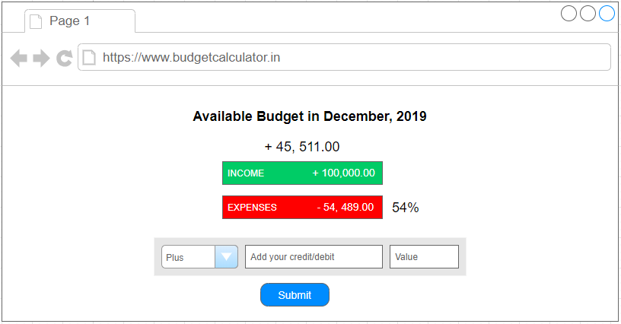

**Mock Up -2**

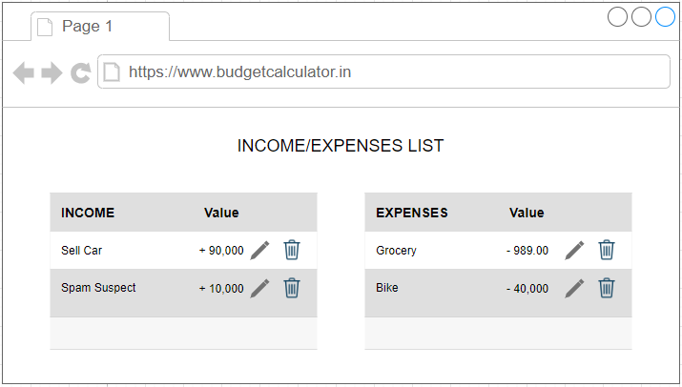

Implementation Guides: -

**Create a budget app of current month: -**

1. Validate user input.
2. Add the income/expenses in the input sections of Credit/Debit.
3. User can delete the income / expenses from the list.
4. Dynamically display the **Total (budget, Income & expenses) values** on add & remove items.
5. Dynamically display the **Total Expense percentage** on add & remove items.
6. Display current month & Year on the top.
7. User can edit the income/expense from the list and simultaneously update the dynamic data.

**Note: -**

* If the percentage is not available, display double dash ‘--’ instead of percentage.
* Do not use any third-party library like Material or Bootstrap.
* Format the number. (90000 -> 90,000)
* Use any features of Angular 4 + and ES6/ES7 JavaScript.

**Technical Approach: -**

1. Can use Reactive/Template driven angular forms.
2. Can use global variable JSON object to maintain data state management.
3. Can use angular services to retrieve records
4. Would be good to have RxJS library to perform HTTP operations.
5. Can use plain CSS in angular component files.
6. Can use angular routing method to redirect/replace to 2nd mock-up screen.
7. Not necessary if Mock-up design is not matching.
8. Can use any mock API service provider. Example: - firebase, fake JSON placeholder